5th Grade Supply List 2023-2024
 | Quantity | Item
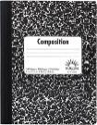 | 4 | Composition Books (speckled, not spiral)
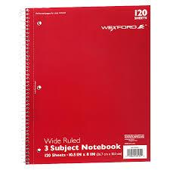 | 2 | 3-subject spiral notebook
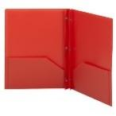 | 5 | 3-hole plastic folders with pockets – no metal brads - (Suggested colors: 1 red, 1 yellow, 1 green, 1 blue, 1 other color)
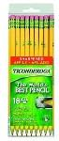 | 4 packages | Pencils
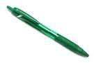 | 3 | Colored pens (red, blue, green)
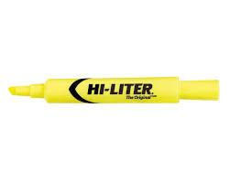 | 2 packages | High-lighters- 4-6 different colors
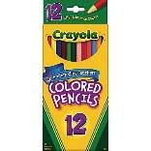 | 1 pack | 12 pack Colored Pencils
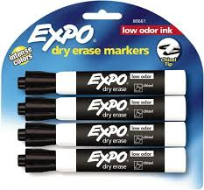 | 2 packs | Black or blue expo markers
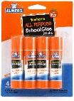 | 4 | 6-count glue sticks (small)
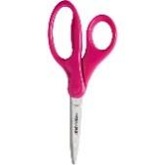 | 1 pair | Child scissors
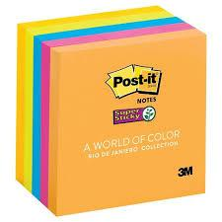 | 2 | Sticky notes – all colors and sizes – lined or unlined
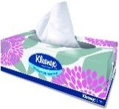 | 2 boxes | Kleenex tissues
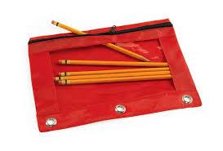 | 1 | Zippered pencil pouch/bag (no pencil boxes please)
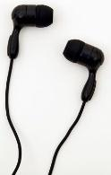 | 1 | Earbuds or Headphones Feel free to have a back up
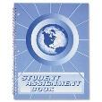 | 1 | Assignment book: purchase @ School Store ($5)
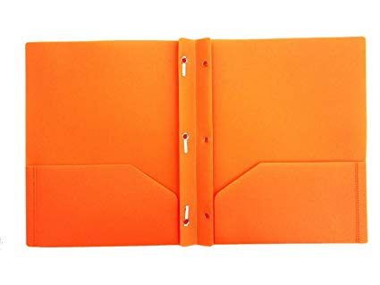 | 1 | ART ROOM WISH LIST ITEM:  3-prong folder
Note: There may be special supply requests for each teacher team. These will be provided at the beginning of the year.
Other “wish list” items:
disinfecting wipes (Clorox Wipes and baby wipes), Ziploc bags (various sizes), hand sanitizer, boxes of Kleenex tissues, hand soap in individual bottles, paper towels, band aids, electric pencil sharpener (heavy duty) for class to use, additional classroom supplies from the list for community use

